ve

**System Admin User Manual v 1.0**

* **Central Equipment Identity Register System Admine Portal**

Document Change History

|  |  |  |  |
| --- | --- | --- | --- |
| Version | Change Type | Description | Date |
| Draft |  | Submitted for internal review | February 2020 |

Contents

Document Change History i

Contents ii

Figures iv

1 Overview 1

1.1 Scope 1

1.2 Acronyms & Abbreviations 1

1.3 Conventions 1

2 System Admin Operations 2

2.1 Application Overview 2

2.2 Logging into the Application 2

2.3 Application User Interface 5

2.3.1 Dashboard 8

2.4 System Management 11

2.5 Edit Parameter 13

2.6 Filter Parameter 13

2.7 Message Management 14

2.8 Edit Message 15

2.9 Filter Message 16

2.10 Port Management 17

2.11 Edit Port Parameters 18

2.12 Filter Port Management 19

2.13 Field Management 19

2.14 Edit Field Parameters 21

2.15 Filter Field Management 21

2.16 Modify Field Management 22

2.17 Currency Management 23

2.18 Edit Currency Parameters 25

2.19 Filter Currency Management 25

2.20 Add Currency Management 26

2.21 Annex 1 28

2.22 Annex 2 29

2.23 Annex 3 29

Figures

Figure 5: Login 3

Figure 6: Home Page 4

Figure 7: Forgot Password 4

Figure 8: Set New Password 5

Figure 9: Home Page 5

Figure 10: Edit Information 6

Figure 11: Change Password 7

Figure 12: Manage Account 8

Figure 13: Home Page 8

Figure 15: Stock Management 9

Figure 16: Grievance Management 10

Figure 18: Home Page 10

Figure 29: System Management – View All 12

Figure 34: System Management - Edit 13

Figure 36: System Management – Filter Option 14

Figure 29: System Management – View All 15

Figure 34: Message Management - Edit 16

Figure 36: Message Management – Filter Option 17

Figure 29: Port Management – View All 17

Figure 34: Port Management - Edit 18

Figure 36: Port Management – Filter Option 19

Figure 29: Field Management – View All 20

Figure 34: Field Management - Edit 21

Figure 36: Field Management – Filter Option 22

Figure 36: Field Management – Filter Option 22

Figure 36: Field Management – Add Value Option 23

Figure 29: Currency Management – View All 24

Figure 34: Currency Management - Edit 25

Figure 36: Field Management – Filter Option 26

Figure 36: Field Management – Filter Option 27

Figure 36: Currency Management – Add Option 27

# Overview

## Scope

The objective of this manual is to help system admin to use and configure the CEIR (Central Equipment Identity Register) application.

## Acronyms & Abbreviations

| **Acronym** | **Full Form** |
| --- | --- |
| CEIR | Central Equipment Identity Register |
| ESN | Electronic Serial Number |
| IMEI | International Mobile Equipment Identity |
| MEID | Mobile Equipment Identifier |
| PDA | Personal Digital Assistant |
| TAC | Type Allocation Code |
| TRC | Telecommunication Regulator of Cambodia |

## Conventions

| **Information** | **Convention** |
| --- | --- |
| UI elements  (such as names of windows, buttons, and fields) | Bold |
| References  (such as names of files, sections, paths, and  parameters) | *Italics* |
| **\*** | Indicates a mandatory field or column |

# System Admin Operations

## Application Overview

The CEIR (Central Equipment Identity Register) System Admin Portal is used to use and configure the CEIR application

System Admins perform the following tasks:

* System Management
* Message Management
* Policy Management
* Audit Management
* Field Management
* Port Management
* Currency Management

## Logging into the Application

Before login, the System Admin must register in the application.

To register:

As part of configuration, system admin login would be provided. The user name is system and password is system. It is advised to change the password.

To login:

1. Open the browser and enter the CEIR System Admin Portal URL in the address bar. The login screen appears.

Figure 5: Login

On the top right corner of the login screen is the **Language** option. The application supports two languages: **English** and **Khmer**. On selecting a given language, all the field and column labels in the application appear in the selected language. All user inputs are, however, in English.

1. Next, enter the assigned login username and password.

Username is the registration ID that is sent on mail to the System Admin after successful registration in the system.

1. Enter the captcha.
2. Click **LOGIN**.

If the login and password are incorrect or the captcha is not correct, an error message appears, and you are prompted to re-enter the login details.

On entering correct information, the application Home page appears.

Figure 6: Home Page

If the System Admin forgets the assigned password, click the **Forgot Password** link on the **Login** page. The **Forgot Password** page appears.

Figure 7: Forgot Password

1. Enter the login username.
2. Select a security question from the list. Select any one of the security questions that were selected during registration.
3. Enter the answer to the selected security question. This should match the answer given at the time of registration.
4. Click **SUBMIT**.

The **Set New Password** page appears.

Figure 8: Set New Password

1. Enter a new password. Click  to see the password characters being entered. Click on it again to hide the password characters. This works like a toggle key.
2. Re-enter the password.
3. Click **Save**

## Application User Interface

On logging into the application successfully, the CEIR System Admin Portal Home page appears.

Figure 9: Home Page

The Home page has all the feature menus on the left panel.

The center of the page is the Dashboard.

The top right corner of the screen displays the following menu options:

* **Download**: Click to download this user manual.
* **English**: Select **English** or **Khmer**. All the field and column labels appear in the selected language. User inputs are, however, in English.

* **Home**: Click on it to go to the **DMC Home Portal** page.
* A close up of a logo

  Description automatically generated(**User profile**): Click on it to see the following menu:

*  (**Edit Info**): Click on it to modify the registered information. The **Edit Information** page opens.

Figure 10: Edit Information

1. Make the required changes.
2. Click **Submit** to save the changes.

*  (**Change Password**): Click on it change the login password.

Figure 11: Change Password

1. **Old Password**: Enter the existing password. Click  to see the password characters being entered. Click on it again to hide the password characters. This works like a toggle key.
2. **New Password**: Enter a new password.
3. **Confirm Password**: Re-enter the new password to confirm the password.
4. Click **SUBMIT**.

*  (**Enable/Disable Account**): System Admins can deactivate their account or disable/enable their account.
  + Deactivating an account means deleting the System Admin’s account. Once the System Admin’s account is deleted, the System Admin can raise a grievance to reactivate it when required. The grievance is sent to the CEIR administrator who reactivates the account. After reactivation, the System Admin can use the same login username and password to log into the application.
  + When the account is disabled, System Admins can only view information and not add or modify information in the application. After the account is disabled, the System Admin can enable it using the same menu.

Figure 12: Manage Account

1. Select **Deactivate** or **Disable**.
2. Click **SUBMIT**.

### Dashboard

The Dashboard provides a quick display and access to the following information:

* Alert/Notifications

Figure 13: Home Page

**Stock**

The stock box displays the total number stock entries pending approval.

Click  (**View)** to access the **Stock Management** dashboard. Refer to *Stock Management* for more information.

Figure 15: Stock Management

**Total Devices Waiting for Upload**

The box displays the total number of devices (IMEIs/MEIDs/ESNs in stock) pending for upload.

Click  (**View)** to access the **Stock Management** dashboard. Refer to *Stock Management* for more information.

**Grievances**

The box displays the total number of grievances that are open.

Click  **(View)** to access the **Grievance Management** dashboard. Refer to *Grievance Management* for more information.

Figure 16: Grievance Management

**Notification Information**

This section displays the ten most recent notifications.

Figure 18: Home Page

Notifications are of two types.

1. Notifications that provide only information. For example, a notification informing the System Admin about the account status is an information only notification because it requires no action. The **View** icon () is disabled in such notifications.



1. Notifications that require some action by the System Admin. For example, a notification about the consignment approval or rejection by the CEIR administrator or customs requires the System Admin to take some action such as fix the errors in the consignment. The **View** icon () is enabled in such notifications. Click  (**View)** to access the relevant page of the notification.



The notification panel has the following columns:

* **Date**: Date of sending the notification
* **Transaction ID**: Transaction ID of the consignment or stock or grievance or type approval request for which the notification is sent. If the notification is related to the System Admin account, the login username is shown instead of any transaction ID.
* **Feature**: This is the name of the feature for which the notification is sent. For example, if the notification is for a consignment, the feature name **Consignment** is shown. If the notification is concerning a stock transaction, the feature name **Stock Management** is shown. The feature name is the one shown in the left panel of the Home page.
* **Message**: This is the message of the notification. An example is shown below.



* **Action**: This shows the **View** icon. It is activated  if the System Admin can click on it else it is disabled .





## System Management

Using this feature, System admin can configure the system parameters. There are two types of parameters:

* System
* User

System parameter are not allowed to be changed and are configured at the time of installation.

User parameter can be changed by system admin. The parameter would come into effect from the next time the new request are processed.

.

To configure parameters:

1. Select **System Management** in the left panel.

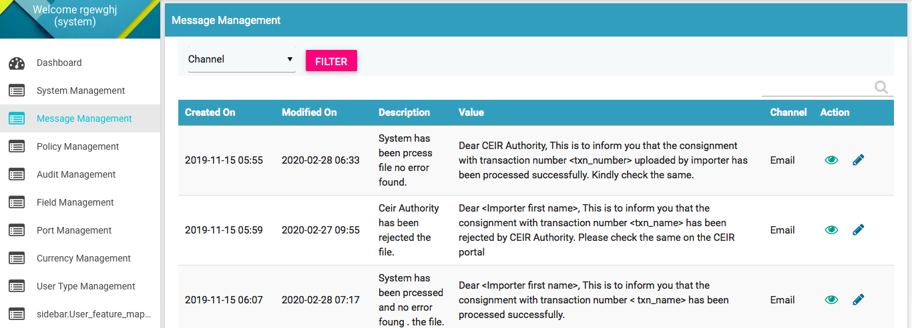

Figure 29: System Management – View All

The following columns are seen in the System Management Page

| **Column** | **Description** |
| --- | --- |
| Created On | This is the date of installation of system. |
| Modified On | Date when parameter is last modified. |
| Description | Description of the parameter. |
| Value | Current Value assigned to the parameter. |
| Type | Whether the parameter is of System or User Type |
| Action | This displays different actions that can be performed on the parameter.   * View : This is used to view the parameter details. * Edit A close up of a logo    Description automatically generated: This is used to modify the parameter details. |

Refer to Annex 1 for complete list of messages.

## Edit Parameter

System Admins can modify the parameter of type user.

To edit parameter:

1. Click **Edit (A close up of a logo

   Description automatically generated)** against the parameter entry to be modified.
2. The **Edit User Parameter** page appears.

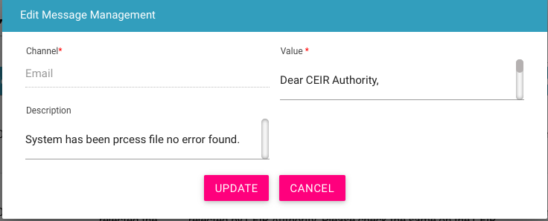

Figure 34: System Management - Edit

1. Make the required changes.
2. Click **UPDATE**.

## Filter Parameter

System Admins can view selective parameters by defining specific values in the listed fields. For example, System Admins can view all the user parameter.

To view specific parameter:

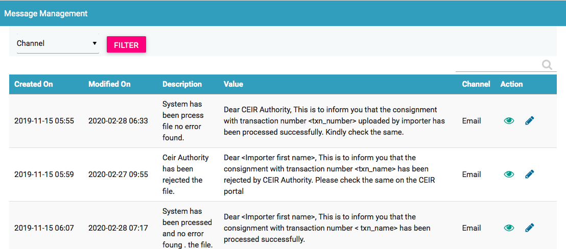

Figure 36: System Management – Filter Option

1. Enter the required value in one or more of the listed fields:

* **Type**: Select the configuration parameter type

1. Click **FILTER**.

The parameter that matches the specified values is shown in the dashboard.

## Message Management

Using this feature, System admin can configure the Email/SMS notification/message to be sent to the users. There are two types of channel using which message can be delivered:

* SMS
* Email

Message parameter can be changed by system admin. The parameter would come into effect from the next time the new request are processed.

To configure message parameters:

1. Select **Message Management** in the left panel.



Figure 29: System Management – View All

The following columns are seen in the Message Management Page

| **Column** | **Description** |
| --- | --- |
| Created On | This is the date of installation of system. |
| Modified On | Date when message is last modified. |
| Description | Description of the message. |
| Value | Current Value assigned to the message. |
| Channel | Whether the channel is of SMS or E-mail |
| Action | This displays different actions that can be performed on the message.   * View : This is used to view the message details. * Edit A close up of a logo    Description automatically generated: This is used to modify the message details. |

Refer to Annex 2 for complete list of messages.

## Edit Message

System Admins can modify the parameter of type user.

To edit parameter:

1. Click **Edit (A close up of a logo

   Description automatically generated)** against the message entry to be modified.
2. The **Edit Message Management** page appears.



Figure 34: Message Management - Edit

1. Make the required changes.
2. Click **UPDATE**.

## Filter Message

System Admins can view selective message by defining specific values in the listed fields. For example, System Admins can view the entire message sent on channel as Email.

To view specific parameter:



Figure 36: Message Management – Filter Option

1. Enter the required value in one or more of the listed fields:

* **Type**: Select the configuration parameter type

1. Click **FILTER**.

The parameter that matches the specified values is shown in the dashboard.

## Port Management

System Admins can configure the custom port information using this feature.

To configure custom port related parameters:

1. Select **Port Management** in the left panel.

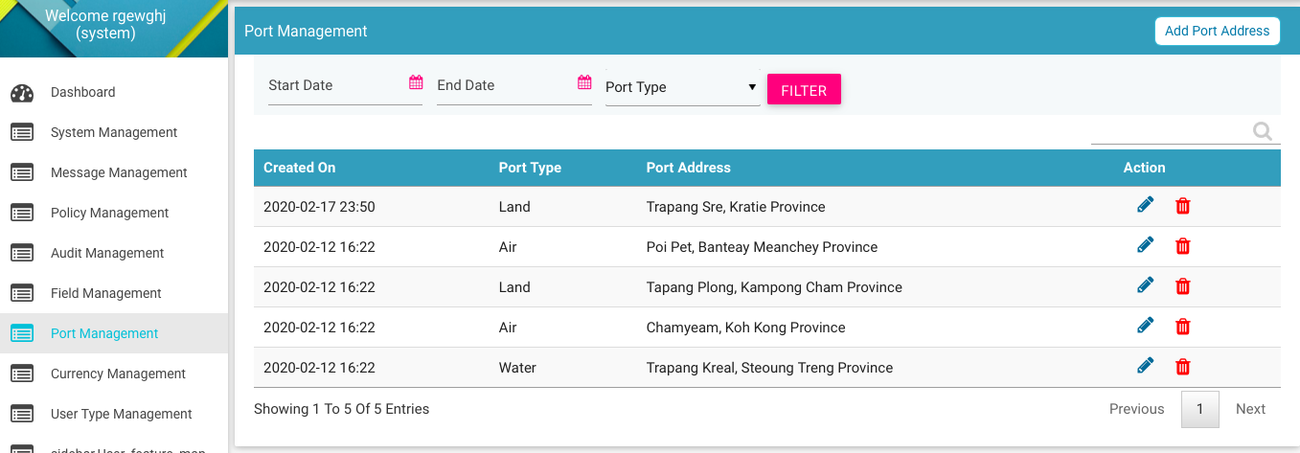

Figure 29: Port Management – View All

The following columns are seen in the Port Management Page

| **Column** | **Description** |
| --- | --- |
| Created On | This is the date of installation of system. |
| Modified On | Date when message is last modified. |
| Port Type | Port Type: Water, Land and Air |
| Port Address | The address of the port. |
| Action | This displays different actions that can be performed on the port parameter.   * View : This is used to view the parameter details. * Edit A close up of a logo    Description automatically generated: This is used to modify the parameter details. |

## Edit Port Parameters

System Admins can modify the port related parameter.

To edit parameter:

1. Click **Edit (A close up of a logo

   Description automatically generated)** against the message entry to be modified.
2. The **Edit Port Management** page appears.

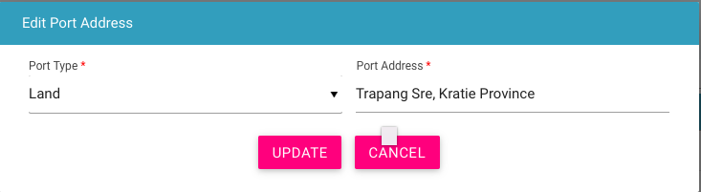

Figure 34: Port Management - Edit

1. Make the required changes.
2. Click **UPDATE**.

## Filter Port Management

System Admins can view selective information by defining specific values in the listed fields. For example, System Admins can view the entire address for port type as Water.

To view specific parameter:

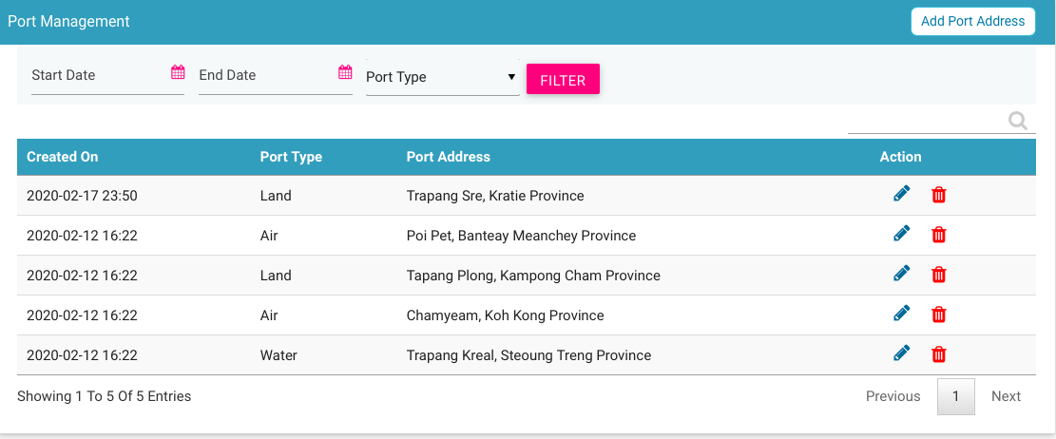

Figure 36: Port Management – Filter Option

1. Enter the required value in one or more of the listed fields:

* **Port Type**: Select the port type

1. Click **FILTER**.

The parameter that matches the specified values is shown in the dashboard.

## Field Management

System Admins can configure the value of various fields in the CEIR system. The fields are the following types:

1. File Fields in the input file as uploaded by stakeholder. For example, importer uploads a file while registering the consignment. The file contains various fields like device type.
2. Form Field that is shown in the form as displayed to the user. For example, the custom registration form has drop down to list down all the port types like water, land and air.
3. Status Field that is shown in the various filters in the form. For example, there is various status of the consignment like NEW, PROCESSING etc. The system contains a state logic based on these field values.
4. System Fields that are shown in the various views in form of tables field values. For example, the alert can be raised or cleared. The value for same is displayed

To configure field parameters:

1. Select **Field Management** in the left panel.

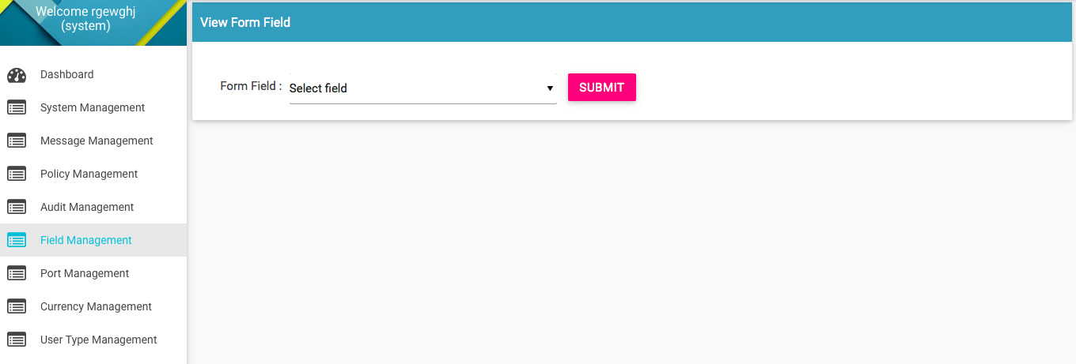

Figure 29: Field Management – View All

The following columns are seen in the Field Management Page once a form field is selected:

| **Column** | **Description** |
| --- | --- |
| Created On | This is the date of installation of system. |
| Modified On | Date when field is last modified. |
| Field | The tag assigned to the field. |
| Display Name | The name that will be displayed on the form |
| Field ID | This is used in special scenarios |
| Description | Description of the field name |
| Action | This displays different actions that can be performed on the field parameter.   * View : This is used to view the field parameter details. * Edit A close up of a logo    Description automatically generated: This is used to modify the field parameter details. |

Field ID is used in special cases. For example, in case of document type, If any document like VAT is uploaded, then the same should be maintained in a separate folder

## Edit Field Parameters

System Admins can modify the field related parameter.

To edit parameter:

1. Click **Edit (A close up of a logo

   Description automatically generated)** against the field parameter entry to be modified.
2. The **Edit Field Management** page appears.

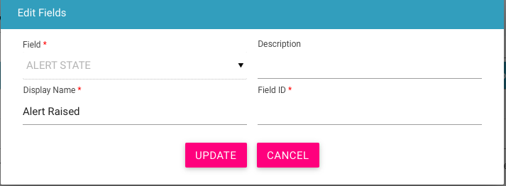

Figure 34: Field Management - Edit

1. Make the required changes.
2. Click **UPDATE**.

## Filter Field Management

System Admins can view selective information by defining specific values in the listed fields. For example, System Admins can view the entire parameter list for a given field type

To view specific parameter:

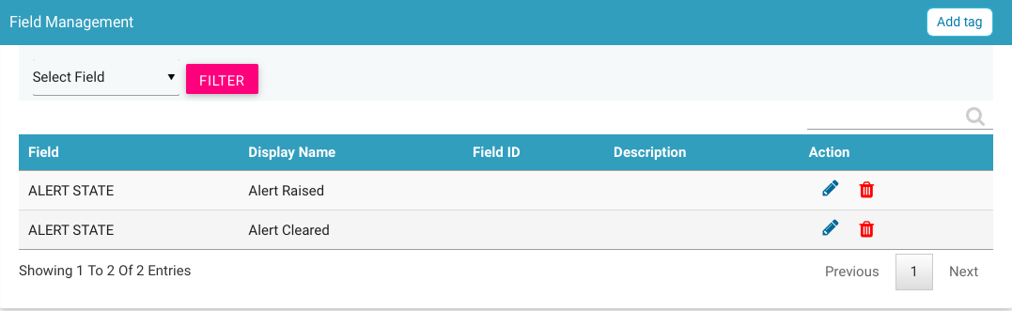

Figure 36: Field Management – Filter Option

1. Enter the required value in one or more of the listed fields:

* **Field**: Select Field

1. Click **FILTER**.

The parameter that matches the specified values is shown in the dashboard.

## Modify Field Management

System Admins can add a new value to existing field in the CEIR system. For example, System Admins can add a new field value in existing field say “ block category”. Once the value is added, then the same is displayed in the drop down option when the operator block the IMEI.

To add new value to specific field:



Figure 36: Field Management – Filter Option

1. Select the field
2. Once field value are displayed, Select the Add Tag option
3. Enter the required value

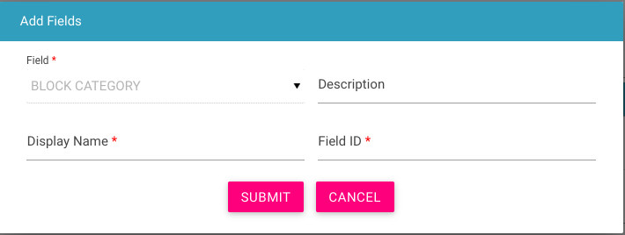

Figure 36: Field Management – Add Value Option

The following columns are seen in the Field Management Page once a form to add a new value is selected:

| **Column** | **Description** |
| --- | --- |
| Field | Field for which new value is to be added. |
| Description | The description of the value |
| Display Name | The value to be shown. |
| Field ID | To be used in special scenarios. |

1. Click **Submit**.

The new parameter is saved.

## Currency Management

System Admins can configure the currency rate on monthly basis for all supported currency in the CEIR system.

To configure currency parameters:

1. Select **Currency Management** in the left panel.

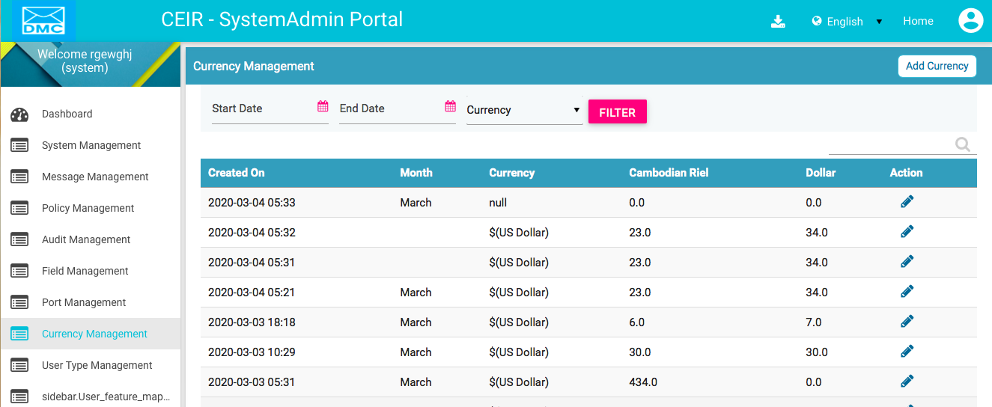

Figure 29: Currency Management – View All

The following columns are seen in the Field Management Page once a form field is selected:

| **Column** | **Description** |
| --- | --- |
| Created On | This is the date of installation of system. |
| Modified On | Date when field is last modified. |
| Month | The month for which the conversion rate are valid. |
| Currency | Currency for which the conversion rate are provided. |
| Cambodian Riel | The conversion rate in Cambodian Riel. |
| Dollar | The conversion rate in US Dollar. |
| Action | This displays different actions that can be performed on the currency parameter.   * Edit A close up of a logo    Description automatically generated: This is used to modify the field parameter details. |

For example, if the currency is Euro, then the conversion rate is mentioned as follows

Value in Cambodian Riel is 4535.52 as 1 Euro is equal to 4535.52 Cambodian Riel

Value in Dollar is 1.12 as 1 Euro is equal to 1.12 US Dollar.

## Edit Currency Parameters

System Admins can modify the currency related parameter.

To edit parameter:

1. Click **Edit (A close up of a logo

   Description automatically generated)** against the field parameter entry to be modified.
2. The **Edit Field Management** page appears.

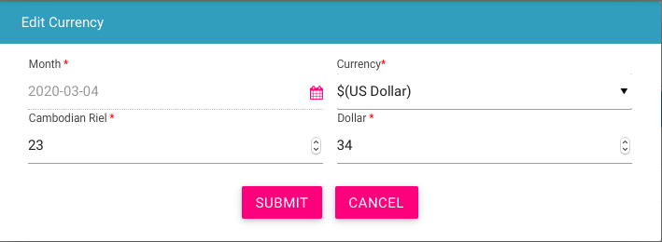

Figure 34: Currency Management - Edit

1. Make the required changes.
2. Click **UPDATE**.

## Filter Currency Management

System Admins can view selective information by defining specific values in the listed fields. For example, System Admins can view the entire parameter list for a given field type

To view specific parameter:

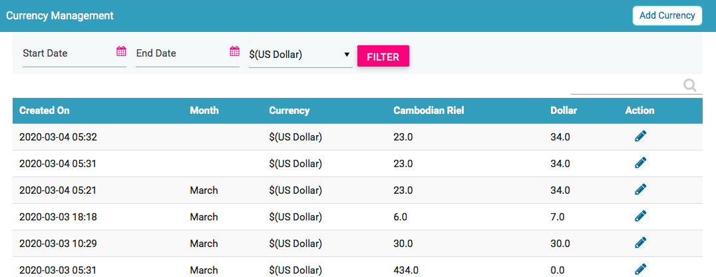

Figure 36: Field Management – Filter Option

1. Enter the required value in one or more of the listed fields:

* **Start Date**: Select Start Date
* **End Date**: Select End Date
* **Currency**: Drop containing the currency list.

1. Click **FILTER**.

The parameter that matches the specified values is shown in the dashboard.

## Add Currency Management

System Admins can add a new conversion rate for a month for all the supported currency in the CEIR system.

To add new conversion rate to given currency:



Figure 36: Field Management – Filter Option

1. Select the Add Currency option
2. Enter the required value

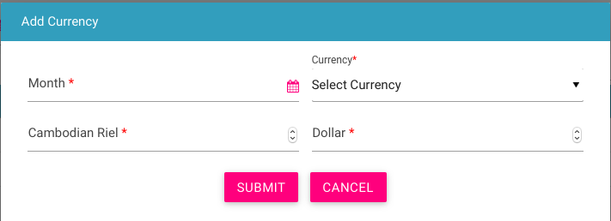

Figure 36: Currency Management – Add Option

The following columns are seen in the Add Currency Page once a form is selected:

| **Column** | **Description** |
| --- | --- |
| Month | The month for which the conversion rate are valid. |
| Currency | Currency for which the conversion rate are provided. |
| Cambodian Riel | The conversion rate in Cambodian Riel. |
| Dollar | The conversion rate in US Dollar. |

1. Click **Submit**.

The conversion rate for currency is saved.

## Audit Management

System Admins can view all the user related activity via this feature

To view user activity:

1. Select **Audit Management** in the left panel.

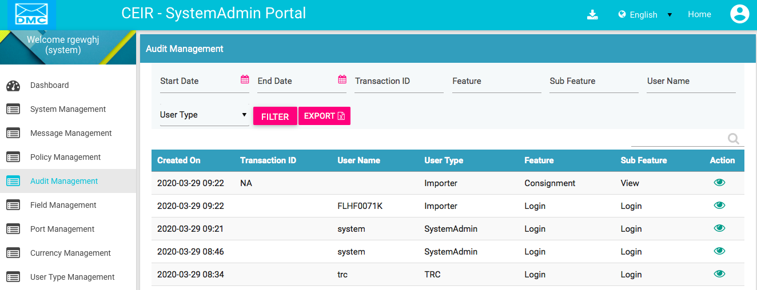

Figure 29: Audit Management – View All

The following columns are seen in the Audit Management Page once a form field is selected:

| **Column** | **Description** |
| --- | --- |
| Created On | The date when the activity is performed. |
| Transaction ID | Transaction ID if any related to that activity. It can also include user name in case of user management related activity |
| User Name | User name of the Stakeholder. |
| User Type | User Type like importer |
| Feature | Name of the feature on which the activity is performed. |
| Sub Feature | The conversion rate in US Dollar. |
| Action | This displays different actions that can be performed on the activity.   * View : This is used to view the activity details. |

## Filter Audit Management

System Admins can view selective information by defining specific values in the listed fields. For example, System Admins can view the entire parameter list for a given field type

To view specific parameter:

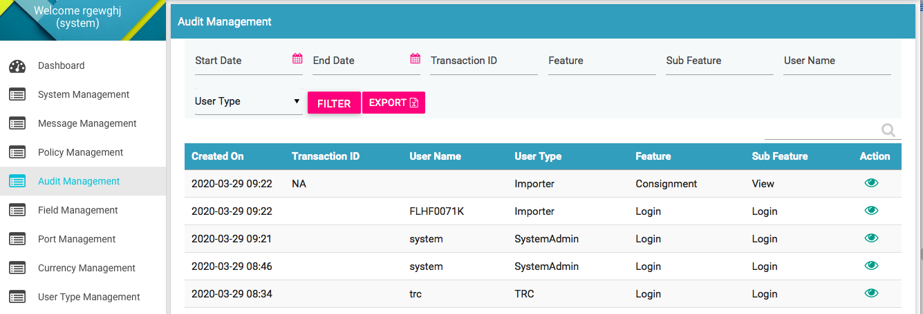

Figure 36: Audit Management – Filter Option

1. Enter the required value in one or more of the listed fields:

* **Start Date**: Select Start Date
* **End Date**: Select End Date
* **Transaction ID**: Enter Transaction ID
* **Feature**: Select Feature Name
* **Sub Feature:** Select Sub Feature Name
* **User Name: Enter User Name**
* **User Type**: Select the

1. Click **FILTER**.

The parameter that matches the specified values is shown.

## Policy Management

System Admins can configure the policy related parameter in both grace an post grace period in the CEIR system.

To configure policy parameters:

1. Select **Policy Management** in the left panel.

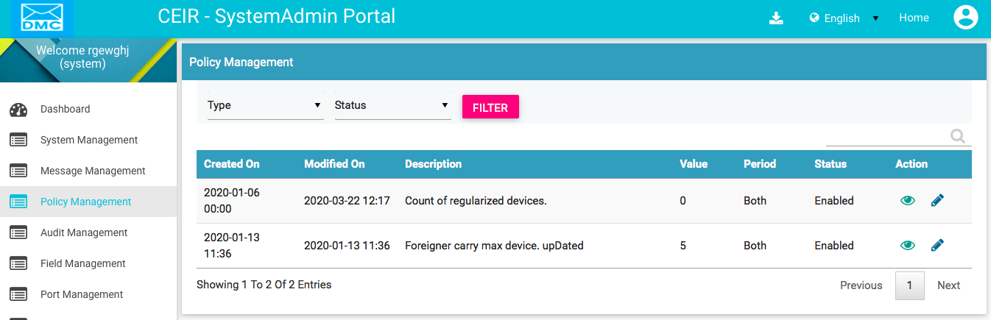

Figure 29: Policy Management – View All

The following columns are seen in the Field Management Page once a form field is selected:

| **Column** | **Description** |
| --- | --- |
| Created On | This is the date of installation of system. |
| Modified On | Date when field is last modified. |
| Description | The description of the policy parameter. |
| Value | Value of the policy parameter. |
| Period | CEIR period for which this parameter is applicable The value can be grace, post-grace or both. |
| Status | Whether this parameter is enabled or not in the system. |
| Action | This displays different actions that can be performed on the currency parameter.   * Edit A close up of a logo    Description automatically generated: This is used to modify the policy parameter details. * View : This is used to view the policy parameter details. |

## Edit Policy Parameters

System Admins can modify the policy related parameter.

To edit parameter:

1. Click **Edit (A close up of a logo

   Description automatically generated)** against the policy parameter entry to be modified.
2. The **Edit Policy Management** page appears.

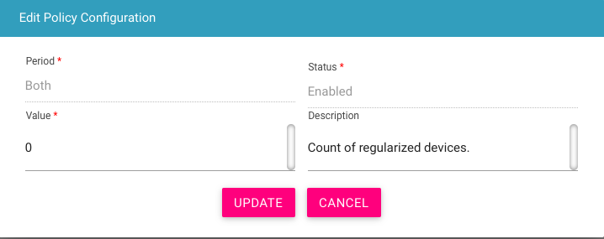

Figure 34: Policy Management - Edit

1. Make the required changes.
2. Click **UPDATE**.

## Filter Policy Management

System Admins can view selective information by defining specific values in the listed fields. For example, System Admins can view the entire parameter list for a type as enabled.

To view specific parameter:

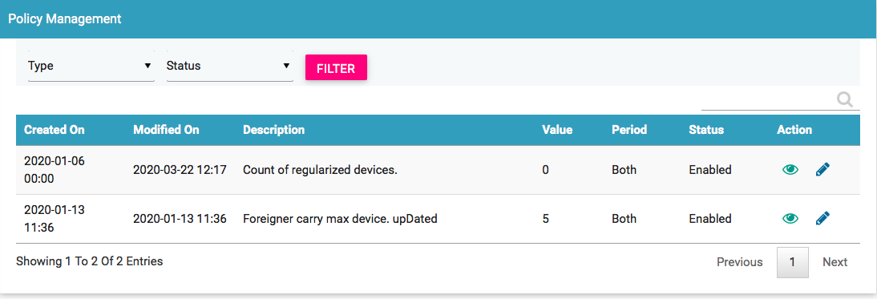

Figure 36: Policy Management – Filter Option

1. Enter the required value in one or more of the listed fields:

* **Type** : Select Type
* **Status**: Select Status

1. Click **FILTER**.

The parameter that matches the specified values is shown in the dashboard.

## Annex 1

This section describes the list of parameters.

The list is categorized based on the different functionality in the system

Register Device Feature Related Parameters

| **Parameter Name** | **Possible Value** |
| --- | --- |
| Date in MM-DD format that decide when the year start for cambodian user. If value is 04-01, it means that the year is from 1 April to 31st March. | 04-01 |
| Time Period in days given to end user to pay custom tax and regularize the device | 30 |
| Visa Expiry Period in days in case visa details are not provided by foreigner while registering the device | 30 |
| Flag to indicate if the Notification is to be sent for Tax not Paid case to end user. | Y. Y stands for Yes and N stand for No |

Blacklist Feature Related Parameters

| **Parameter Name** | **Possible Value** |
| --- | --- |
| Base Path from where full and incremental blacklist file would be maintained in the CEIR system | /var/www/html/downloads/blackListFiles/ |
| Time Period in days when the Full Blacklist file would be generated in the CEIR system. | 7 |
| Time Period in days when the Incremental Blacklist file would be generated in the CEIR system | 1 |
| Base URL from where full and incremental Blacklist file would be available for download by operator from the CEIR system. | http://13.127.239.247/downloads/blackListFiles/ |
| Dirty Period in days for which the blacklist number found in GSMA are maintained in the CEIR system. | 180 |

Greylist Feature Related Parameters

| **Parameter Name** | **Possible Value** |
| --- | --- |
| Base Path from where full and incremental Greylist file would be maintained in the CEIR system | /var/www/html/downloads/greylistFiles/ |
| Time Period in days when the Full Greylist file would be generated in the CEIR system. | 7 |
| Time Period in days when the Incremental Greylist file would be generated in the CEIR system | 1 |
| Base URL from where full and incremental Greylist file would be available for download by operator from the CEIR system. | <http://13.127.239.247/downloads> /greyListFiles/ |
| Time Period in days when the IMEI will move from greylist to blacklist in the CEIR system. | 30 |
| Day of the Week in MMM format on which Greylist or Blacklist will be generated by CEIR system. This parameter is valid only when frequency is weekly (7 days). | Sun |

Operator CDR Feature Related Parameters

| **Parameter Name** | **Possible Value** |
| --- | --- |
| Value of Mobile Country Code (MCC) for Cambodia | 855 |
| Base Path where ETL system uploads the CDR files via FTP in the CEIR system | /home/ubuntu/ETL |
| Maximum Number of one IMEI mapped to different MSISDN to avoid duplicate count | 5 |

Grievance Feature Related Parameters

| **Parameter Name** | **Possible Value** |
| --- | --- |
| Time Period in days given to user to respond to grievance. Post expiry, the grievance is marked as closed by the CEIR system | 10 |
| Maximum number of document that can be uploaded at the time of raising grievance | 3 |

Notification Feature Related Parameters

| **Parameter Name** | **Possible Value** |
| --- | --- |
| Mail Signature to be added at the end of each mail sent from the CEIR system | Regards  CEIR Admin |
| Number of Notifications to be displayed in descending order on Dashboard for all users | 10 |
| Time Period in days before which reminder has to be sent before action is to be taken by CEIR system | 3 |

SLA Feature Related Parameters

| **Parameter Name** | **Possible Value** |
| --- | --- |
| SLA Breach period in days to approve the consignment by CEIR Admin | 3 |
| SLA Breach period in days to reply to grievance by CEIR Admin | 3 |
| SLA Breach period in days to approve the stock uploaded by stakeholder or endusers | 3 |

Stolen/Recovery Feature Related Parameters

| **Parameter Name** | **Possible Value** |
| --- | --- |
| Time Period in days to look in operator CDR in case mobile number is only provided in stolen device case | 10 |

TAC Feature Related Parameters

| **Parameter Name** | **Possible Value** |
| --- | --- |
| API Key to be used in TAC HTTPS API provided by GSMA | ZqXBvdRLYRiAWCO |
| Password to be used in TAC HTTPS API provided by GSMA | LdTcsQYaYuxRabQ |
| Salt String to be used in TAC HTTPS API provided by GSMA | GSMA |
| Organization ID to be used in TAC HTTPS API provided by GSMA | 9101 |
| Secret Key to be used in TAC HTTPS API provided by GSMA | imeaesencryption |
| TAC HTTPS API provided by GSMA | <https://imeidb.gsma.com/services/rest/GetHandSetDetails> |
| Dirty Period in day for which the TAC number not found in GSMA are maintained in the CEIR system. | 30 |

User Management Feature Related Parameters

| **Parameter Name** | **Possible Value** |
| --- | --- |
| Base URL Link of DMC Home Page where the user request would be redirected on Home / New user request | http://13.233.39.58:8080/CEIR/DMC |
| Time period in days post expiry the user password will expire | 180 |
| Base URL for downloading User Manual | http://13.233.39.58:8080/Design/manuals/ |
| Maximum number of registration allowed for all user types in the CEIR system | 500000 |
| Maximum number of registration allowed for user type as Importers in the CEIR system | 1000 |
| Maximum number of registration allowed for user type as Distributors in the CEIR system | 10000 |
| Maximum number of registration allowed for user type as Retailer in the CEIR system. | 100000 |
| Maximum number of registration allowed for user type as Custom in the CEIR system | 100 |
| Maximum number of registration allowed for user type as Operators in the CEIR system | 100 |
| Maximum number of registration allowed for user type as TRC in the CEIR system | 10 |
| Maximum number of registration allowed for user type as Manufacturer in the CEIR system | 100 |
| Maximum number of registration allowed for user type as Lawful Agency in the CEIR system | 100 |
| Maximum Number of device registration allowed for user type as End User in the CEIR system | 10000 |
| Maximum number of registration allowed for user type as Immigration in the CEIR system | 100 |
| Maximum number of registration allowed for user type as Customer Care in the CEIR system | 100 |

## Annex 2

This section describes the list of message that is sent as notification to user either via SMS or Email.

The list is categorized based on the different functionality in the system.

Block Device Feature Related Messages

| **Parameter Name** | **Possible Value** |
| --- | --- |
| Message sent to Operator or CEIR Authority when the CEIR admin has approved the request to block devices | Dear <first name>,  This is to inform you that the your block request with transaction number <txn_name> has been approved by CEIR Authority. |
| Message sent to Operator or CEIR Authority when the CEIR admin has rejected the request to block devices | Dear <First name>,  This is to inform you that the block request with transaction number <txn_name> has been rejected by CEIR Authority. |
| Message sent to CEIR Authority when the system has processed the block request successfully | Dear <First name>,  This is to inform you that the block request with transaction number <txn_name> has been processed by system successfully. |
| Message sent to CEIR Authority when the system has processed the block request successfully | Dear CEIR Authority,  This is to inform you that the block request with transaction number <txn_name> has been processed by system successfully. |

Stolen Device Feature Related Messages

| **Parameter Name** | **Possible Value** |
| --- | --- |
| Message sent to Lawful Agency when the CEIR admin has approved the request for stolen devices | Dear <first name>,  This is to inform you that the your Stolen request with transaction number <txn_name> has been approved by CEIR Authority. |
| Message sent to Lawful Agency when the CEIR admin has rejected the request for stolen devices | Dear <First name>,  This is to inform you that the stolen request with transaction number <txn_name> has been rejected by CEIR Authority. |
| Message sent to Lawful Agency when the system has processed the stolen request successfully | Dear <First name>,  This is to inform you that the stolen request with transaction number <txn_name> has been processed by system successfully. |
| Message sent to CEIR Authority when the system has processed the stolen request successfully | Dear CEIR Authority,  This is to inform you that the stolen request with transaction number <txn_name> has been processed by system successfully. |

Unblock Device Feature Related Messages

| **Parameter Name** | **Possible Value** |
| --- | --- |
| Message sent to Operator or CEIR Authority when the CEIR admin has approved the request to unblock devices | Dear <first name>,  This is to inform you that your Unblock request with transaction number <txn_name> has been approved by CEIR Authority. |
| Message sent to Operator or CEIR Authority when the CEIR admin has rejected the request to unblock devices | Dear <First name>,  This is to inform you that your Unblock request with transaction number <txn_name> has been rejected by CEIR Authority. |
| Message sent to Operator or CEIR Authority when the system has processed the unblock request successfully | Dear <First name>,  This is to inform you that the unblock request with transaction number <txn_name> has been processed by system successfully. |
| Message sent to CEIR Authority when the system has processed the unblock request successfully | Dear CEIR Authority,  This is to inform you that the unblock request with transaction number <txn_name> has been processed by system successfully. |

Recovery Device Feature Related Messages

| **Parameter Name** | **Possible Value** |
| --- | --- |
| Message sent to Lawful Agency when the CEIR admin has approved the request for recovered devices | Dear <first name>,  This is to inform you that the your recovery request with transaction number <txn_name> has been approved by CEIR Authority. |
| Message sent to Lawful Agency when the CEIR admin has rejected the request for recovered devices | Dear <First name>,  This is to inform you that the recovery request with transaction number <txn_name> has been rejected by CEIR Authority. |
| Message sent to Lawful Agency when the system has processed the recovered request successfully | Dear <First name>,  This is to inform you that the recovery request with transaction number <txn_name> has been processed by system successfully. |
| Message sent to CEIR Authority when the system has processed the recovered request successfully | Dear CEIR Authority,  This is to inform you that the recovery request with transaction number <txn_name> has been processed by system successfully. |

Consignment Feature Related Messages

| **Parameter Name** | **Possible Value** |
| --- | --- |
| Message sent to Importer when system has rejected the consignment due to processing errors | Dear <user name>,  This is to inform you that the consignment with transaction ID: <txn_id> uploaded by you contains error. Please rectify the file and resubmit the request. |
| Message sent to CEIR Authority when system has processed the consignment successfully | Dear CEIR Authority,  This is to inform you that the consignment with transaction ID: <txn_id> uploaded by importer has been processed successfully. Kindly approve the same. |
| Message sent to Importer when CEIR Authority has been rejected the consignment | Dear <user_name>,  This is to inform you that the consignment with transaction ID: <txn_id> has been rejected by CEIR Authority with the following reason: <reason> |
| Message sent to Importer when system has processed the consignment successfully | Dear <user_name>,  This is to inform you that the consignment with transaction ID: <txn_id> has been processed successfully |
| Message sent to CEIR Authority when custom has processed the consignment successfully | Dear CEIR Authority,  This is to inform you that the consignment with transaction ID: <txn_name> has been approved by customs. |
| Message sent to Importer when Customs has processed the consignment successfully | Dear <user name>,  This is to inform you that the consignment with transaction ID: <txn_name> has been approved by customs. |
| Message sent to Importer when Customs has rejected the consignment | Dear <user_name>,\  This is to inform you that the consignment with transaction ID <txn_name> has been rejected by customs with the following reason: |

User Management Feature Related Messages

| **Parameter Name** | **Possible Value** |
| --- | --- |
| Message sent to user to verify his email ID during registration process errors | Dear <user_name>,\  \  The One Time Password (OTP) for your online registration on CEIR Portal is <number>. \  This OTP is valid for 10 minutes or 1 successful attempt whichever is earlier. \  \  Please do not share this One Time Password with anyone.\contains error. Please rectify the file and resubmit the request. |
|  |  |
|  |  |
|  |  |
|  |  |

Stock Feature Related Messages

| **Parameter Name** | **Possible Value** |
| --- | --- |
| Message sent to user to verify his email ID during registration process errors | Dear <user_name>,\  \  The One Time Password (OTP) for your online registration on CEIR Portal is <number>. \  This OTP is valid for 10 minutes or 1 successful attempt whichever is earlier. \  \  Please do not share this One Time Password with anyone.\contains error. Please rectify the file and resubmit the request. |

## Annex 3

This section describes the list of fields that are displayed in the form.

The list of field is as follows:

| **Field** | **Description** | **Type** | **Possible Values** | **Remarks** |
| --- | --- | --- | --- | --- |
| Alert State | The different type of states of a alert | System | Raised  Clear | This should not be changed. |
| AS Type | The organization type used in registration form | Form | Individual  Company  Organization | This should not be changed. |
| Block Category | The category against which IMEI can be marked as blocked by operator | Form | Contract Violation  Other | A new value for this field can be added here. |
| Channel | The different channel using which notification can be sent | System | E-mail  SMS | This should not be changed. |
| Complaint Type | Type of complaint when stolen device is reported | System | Lost  Stolen | This should not be changed |
| Config Type | The different type of configuration parameters | System | System  User | This should not be changed |
| Currency | The different currency supported in the system | Form | $ (US Dollar)  Euro  Riel | A new value for this field can be added here. |
| Customs Port | The different custom port supported in the system | Form | Water  Land  Air | This should not be changed |
| Custom Tax Status | The different status set to IMEI for the device for which tax to be paid at customs | Status | Tax Paid  Tax Not Paid  Regularized  Blocked | This should not be changed |
| Delete Flag | The different status set to delete request while processing it at the system end. | Status | New  Processing  Deleted | This should not be changed |
| Device Status | The different device status supported in the system | System | NEW  OLD | This should not be changed |
| Device ID Type | The different device ID type supported in the system | System | IMEI  MEID  ESN | This should not be changed |
| Device Type | The different device type supported in the system | System | Handheld  Mobile Phone/Feature Phone  Vehicle  Portable  Module  Dongle  WLAN Router  Modem  Smartphone  Connected Computer | This should not be changed |
| Doc Type | The different document type supported in the system | System | Passport Document  Visa Document  National ID Document  Photo  Other  TAC certificate  FIR document  VIP Department ID  VAT Document  Technical Specification | This should be not be changed  Field ID denote the folder name that will be created where the file is saved in the system. |
| File Type | The various file type supported in the system for generating greylist/black list files | System | Full  Incremental | This should not be changed |
| Grievance Category | The various category supported while raising grievance in the system | System | Consignment  Block/Unblock  Greylist  Blacklist  Type Approval  Register Device  Manage Users  Device Activation  Stolen/Recovery  Stock | This should not be changed |
| Is Active | This denotes if the field parameter is enabled to be used in the system | System | Disabled  Enabled | This should not be changed |
| Multi SIM Status | The field denote if the device support multiple SIM slot or not. | System | Yes  No | This should not be changed |
| Operators | The field denote all the operator supported in the system | System | Smart  Metfone  Seatel  Cellcard | This should not be changed  Field ID denotes type of operator. Value is GSM or CDMA |
| Process Action | The field denote different type of action taken once the CDR record is processed in the system | System | Sys_Reg  Blocked  Allowed  User_Reg | This should not be changed |
| REQ Type (Request Type) | The field denote different type of request supported related to stolen/block cases | System | Stolen  Recovery  Block  Unblock | This should not be changed |
| Role Type | The various role supported for different user type (end user and importer) in the system | System | Importer  Distributor  Retailer  Cambodian  Expat  Foreigner  Tourist  VIP | This should not be changed |
| Source Type | The various request types supported for different stolen/bulk cases | System | Bulk  Single  Individual  Company | This should not be changed |
| Supported languages | The various language supported in the system | System | English  Khmer | This should not be changed |
| Visa Type | The various visa type supported in the system | System | Tourist  Other | This should not be changed |

## Annex 4

This section describes the policy parameter that is defined in the system.

The list of policy parameters is as follows:

| **Description** | **Type** | **Possible Values** | **Remarks** |
| --- | --- | --- | --- |
| Number of devices allowed to Cambodian user while coming back to Cambodia | System | 0 | This should not be changed. |
| Number of devices allowed to Foreigner user while coming to Cambodia in one visit | System | 5 | This value can be changed. |